Newstead Terraces News
August 2013
Garage cleaning is complete for another year. All the overhead pipework has been water blasted, the walls, the drains and the floor have been cleaned. You might not know, but my management contract is to pressure wash the common areas only, this is the driveway and the visitor’s car park. Those of you that know me, know that I could not settle for a job half done, and it was a pleasure for me to clean each individual owner’s car space for you whilst I was there.
Thank you so much to everyone for assisting with staying out of the car park on your designated day. I know this is a bit of an imposition on your busy lives, and I hope that you found the lovely clean car park worth the inconvenience. I have taken a photo of the work in progress (deliberately blurred the cars to protect the identity of the innocent!) so you can see the amount of black tyre dust that builds up in the garage. The image of the bucket is the amount of silt and dust from the first day of cleaning. This is taken from the perimeter drains. Definitely need a manicure after this little task…
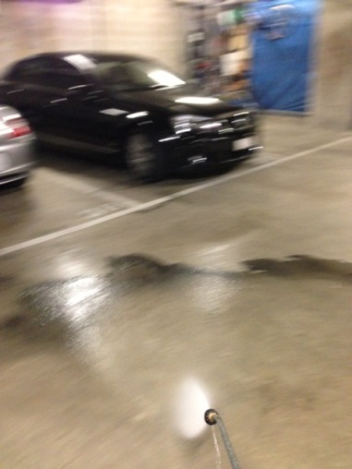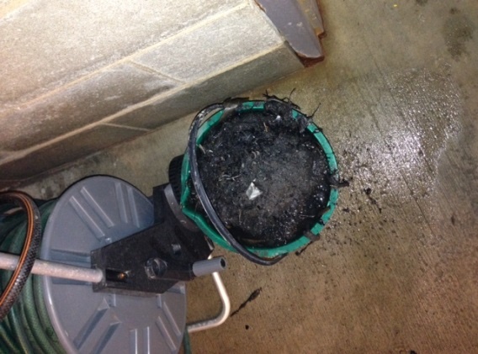
Next months task is the pool area. A big prune planned ready for Summer.
Exciting news for all of us living in the area! The new Gasworks shopping centre opened this week. A soft opening, not everything is finished yet, but the Woolworths is big and well stocked and a true rival for Coles Newfarm, with two draw backs, they don’t open till 8.00am and if you don’t buy anything you have to pay for parking. $5 for the first half hour. Plan you trip, walk if you can.
A little tip for anyone that has a calcium build up on their tiles from water drips, use a bit of hydrochloric acid painted on with a paint brush and sponged off with water. Be careful. Follow the instructions, and use only on external tiles. It also lifts rust marks a little.
Have fun. Georgina

