Newstead Terraces News: August 2012

Dear Residents,

Thank you so much to everyone for the great spirit of co-operation and assistance given during the garage cleaning. I am acutely aware of the inconvenience it causes to find alternative car parking for the day and to not use the garage during the day. It’s a big job and so much easier to do if the garage is empty and the drive ways not being used. This year we tackled the drains as well, cleaning out years of dirt and debris and servicing the 7 pump stations at the same time. I was the mud monster for a few days, covered head to toe in dirt and sludge! But it was so worth it. I think the garage is looking very spick and span at the moment, and I hope that you can all get as much enjoyment and pride out of the finished effect as I do.

Just a quick reminder that it is contrary to Body Corporate By laws to store anything other than bicycles in your car storage bay. There are a few items in the car bays that really should be removed. If you have items stored down in the garage that shouldn’t be, may you please have them removed asap. This includes car batteries, flower arrangements, motor oils and spare parts, ladders, eskies and building materials.

The painters are making great progress, moving onto the Newstead Terraces high rise side of the building. The walkways and stairwells are looking nice and fresh. What a difference a new coat of paint makes! Please remember that they are pressure washing before painting, so if you get a notice under your door that they will be there in the next day or two, please make sure you move your precious items inside so that they don’t get wet. If you were planning on cleaning your glass windows and sliding doors, it might be a good idea to wait until they painters have been past, because you will need to clean after they have been through. I have included a picture of the cherry picker and painters in action on Newstead Terrace on 28-08-12 for your interest. You might also notice that we have finally had the council prune the trees on the footpath! Now the grass might grow again….

For our Landlords, the ATO has issued a list of what can be claimed as a tax deduction. You might find it interesting to see just what you may be able to claim….and when….http://reiq.informz.net/reiq/data/images/enews/rental-property-deductions.pdf
.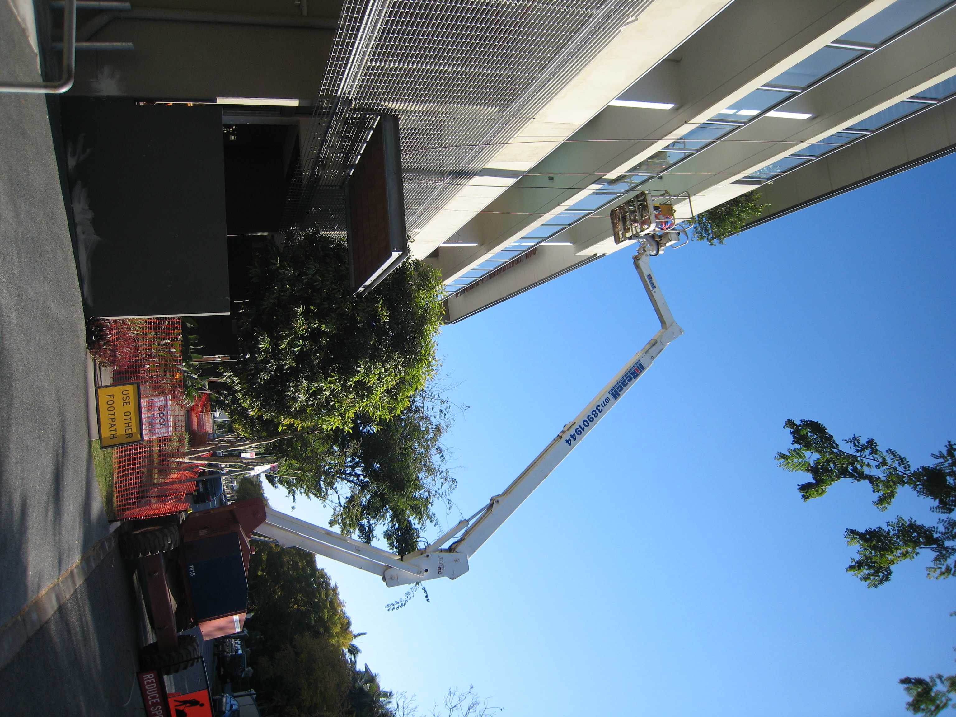
Late news

One of the storage lockers was riffled over the weekend. The lock was still in tact, and nothing was taken but all the bags where opened and the contents gone through.

Please make sure that you are not storing anything of value in the storage cages .

