Newstead Terraces News
August 2015
Hello everyone.
It has been a particularly busy month this month at Newstead Terraces. Following is a snap shot of some of the activities performed in the last month.
Best news – The Deck Beautification underway.
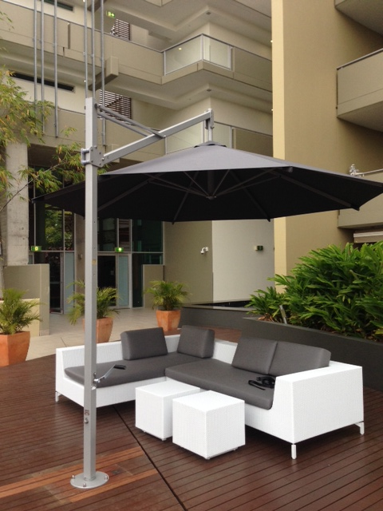
Finally we are starting to see some the results of the year- long efforts of the deck beautification committee. The furniture arrived first. The umbrellas were installed last Thursday and the pots are being unloaded from the ship as I write. We can expect to see the pots, plants and irrigation system to be delivered and installed during September. Once all the installations are complete we will repaint the deck boards that have had to be moved.
I think everyone will agree that the new furniture placement has significantly changed the feel of the common area already. I am so excited to see the impact that the pots and plants will make.

Construction news from Next door.
Demolition of the remaining building structures starts in September. We will have some hoarding erected on our side of the boundary, particularly in the walkway to Austin Street past U18 as the boundary of both properties has conjoined structures. The hoarding represents a “temporary exclusion zone”. This is to keep us safe from any falling objects as the demolition proceeds. There will be some noise and dust, but the asbestos is all painted in under the areas we can see with white paint on it. This will be dismantled piece by piece and by hand to stop any asbestos fibres from being released.

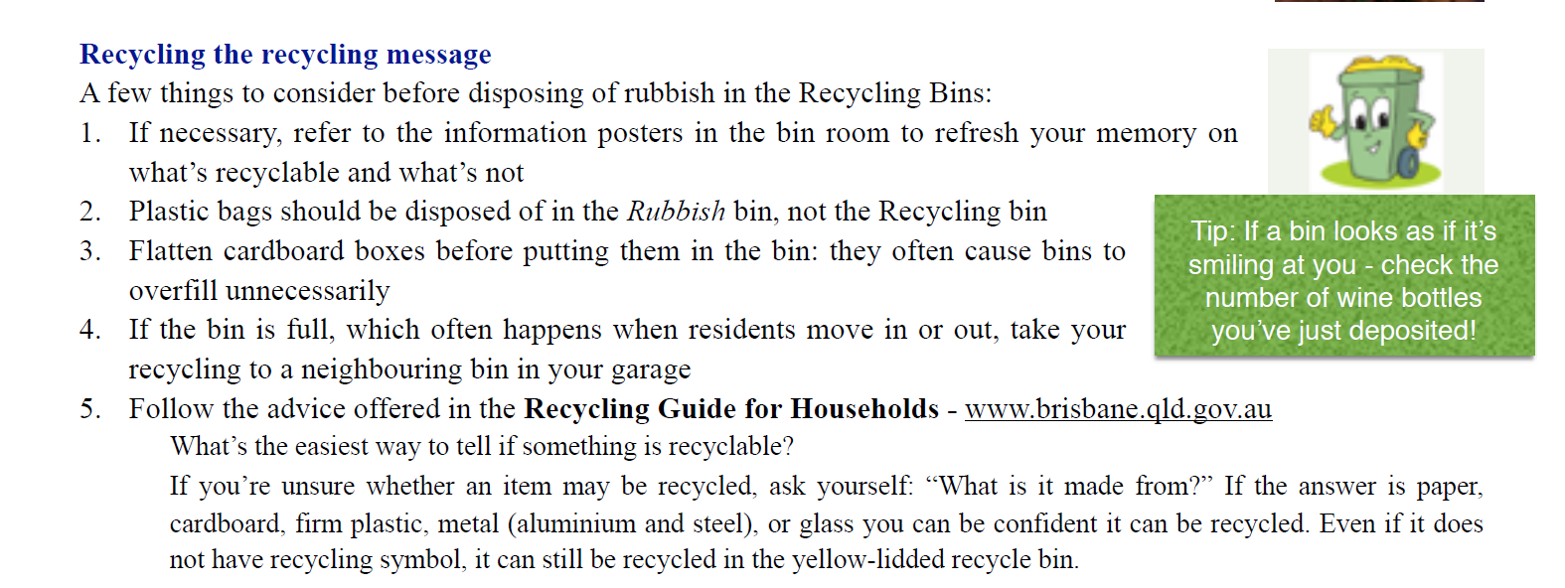
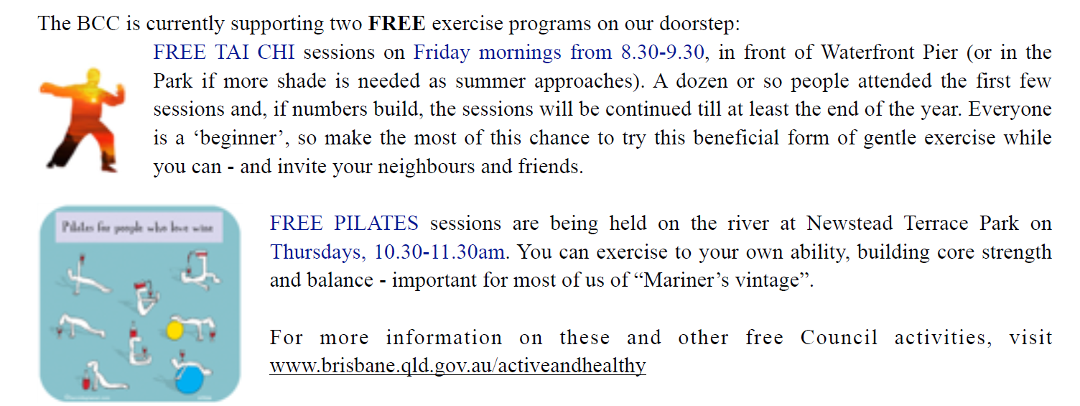
Scandinavian Spectacular
The Danish Club in Austin Street is hosting The Scandinavian festival Sunday the 13th of September between 10am-4pm. Every year this festival grows in size and activities. Here is an opportunity to sample the best of Scandinavian Culture right on our door step. Please be aware that Austin Street is closed to cars from early in the morning of Sunday 13th.
Annual Garage Clean
Thanks everyone for your co-operation with moving cars and making alternative arrangements to facilitate the Annual Garage Pressure Wash. I don’t know about you, but I love the way the garage smells after the job is complete… A special thanks to Committee Member Barry Leask for giving much needed assistance with the degreasing in advance of the pressure washing. I hope you enjoy the lovely clean garage and drains for another year.
Till next month. Stay safe.
Georgina & Doogle.

