Newstead Terraces News
December 2015
Hello Everyone.

Construction Next Door and the Dilapidation Report
The community voted to accept the proposed Over sail and Underpinning agreement reached with our neighbours at the EGM on 10th Dec. It is anticipated that work will commence Early February, weather permitting.
The last step before construction begins is to complete the comprehensive Dilapidation Report. This report records the condition of our property before construction commences. High Definition Photo’s are taken which will allow very detailed examination of specific areas years down the track to determine if any damage that occurs in the future was a result of the construction next door, or was pre-existing. The developers pay for this research, and will need access to every unit and all the common areas over a 4 day period, commencing on Tuesday 27th January. This date is not locked in yet, but rather one we are all trying to work towards. It is in our best interests to be co-operative and allow access to all areas for this report to be worthwhile.
Office Hours over the Christmas Break
Just a reminder: that the office will be closed for all but emergencies, from Wednesday 23rd December to Wednesday 7th January. I will be available on the landline (remember this number diverts to whomever is on call) 38526928 if the situation is desperate. I will be out of town, so if you lock yourself out of your apartment on New Year’s Eve and ring me at 3.00am to let you in, I will most likely answer the phone, but I won’t be able to come and help you out. The locksmiths charge $395 to come and let you in on New Year’s Eve and public holidays. It’s cheaper to stay in a hotel, or at a friend’s place… Just thinking ahead….
A spot in the limelight!
Newstead Terraces had a modelling gig this month. Pillow talk did a photo shoot for an upcoming marketing campaign in and around our common areas. Obviously the product was the hero for the shoots, but see if you can recognize where these lovely images were taken. Thank you to Pillow Talk for sharing the photo’s and for choosing us to host the shoot.
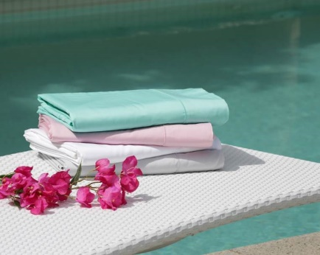

A reminder for the party season to all residents
Noise, smoking, and pool use, are the big three issues for the holiday season. Please try and be mindful that we are all living in a close environment. Your conversation on the balcony is not a private matter, and those on the balcony above, below and beside can hear every word. Your political ideals, your funniest jokes and your most intimate details probably should not be shared with your neighbours especially after 10.00pm and absolutely not when fuelled by Christmas cheer. A good rule of thumb is to take the conversation indoors. Turn on the air conditioning and close the door. That way everyone gets to enjoy the peaceful environment that our balconies and lounge rooms should be.
If you are planning a party, great, but please think how you would like to be treated by your neighbours if they were having a party. Popping a note into your neighbour’s letterbox is a considerate way to let them know and allows them time to plan to be out or away if the noise is going to be an issue for them. If the party is really pumping and it’s getting close to midnight, consider encouraging your guests to take the party to the valley or the city and continuing on there. At the very least, you should get everyone in off the terrace and behind the closed lounge room doors and turn on the air conditioning.
Please remember not to take glass into the pool area. Should a glass break in the pool, the pool has to be emptied and all the glass cleaned out and then refilled. This is not a cheap exercise and the bill will be passed onto you. There are CCTV cameras on the pool area, so no hope of getting away with it. Please also be considerate with the hours you use the pool and the noise you are making in the common areas.
Most importantly, please, please be aware of the pool gates shutting firmly behind you. It would be awful if one of our young residents or visiting guests were to drown in our pools. May I please ask that everyone be very conscious of the smaller members of our community and their proximity to any bodies of water over the holiday season.
Smoking. Those that do smoke don’t seem to be able to smell smoke and those that don’t, can’t get away from the smell of the smoke. If you are a smoker, please be conscious of which direction the smoke is going in. If one of your neighbours asks you to move or to stop, don’t be offended, just try to find a spot that your habit doesn’t affect your neighbours. There is a designated smoker’s area at the front entrance. This is the only common area that smoking is permitted. Smokers, may I ask that if there is a bit of an accumulation of butts in the smokers tin whilst I am on holidays, would you please help me out and pop them into the bin every now and again. May everyone pick up a butt if they see it and put it in the bin.
Loving the Christmas Lights
I just have to say that I love the effort the community have gone to this year. The Christmas lights in the apartments look fabulous and of course, compliment beautifully our own common area lighting. I am feeling really proud of the way our complex is presented, and very proud of our community ownership of the general maintenance and presentation of the property. Thank you everyone for your great efforts and commitment to keeping our home a great place to live.

Have a Merry Happy Christmas and a safe and fun New Years Eve. G

