Newstead Terraces News
November 2015
Hello Everyone.

Deck Beautification update
It’s done! And if you don’t mind me saying so, it is fantastic. We can slowly add a new umbrella if we wish next year, and put in a third seating area when the budget allows. It is proving popular with residents out using the facilities on the weekends. The old outdoor tables and chairs are to be sold. If you think you might like some or know someone whom might like to buy them please give me a call because I can do a deal for you!

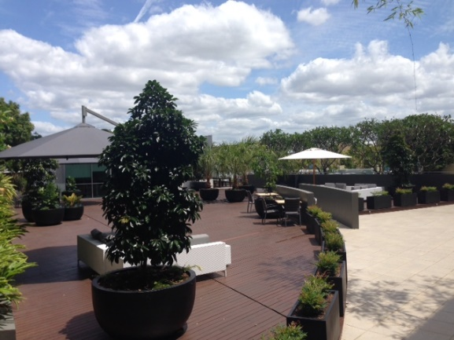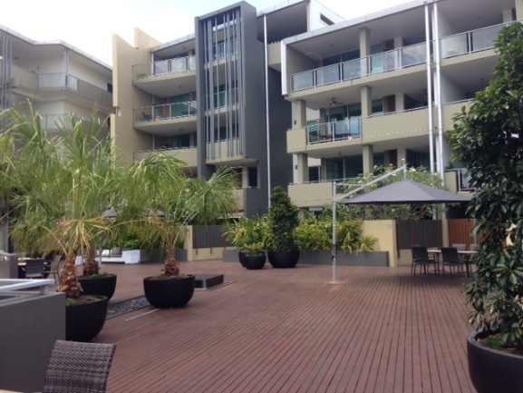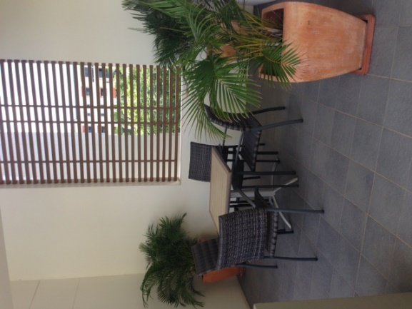Furniture and old palms have been recycled onto upper balconies.
Office Hours over the Christmas Break
Just a reminder: that the office will be closed for all but emergencies, from Wednesday 23rd December to Wednesday 7th January. I will be available on the landline (remember this number diverts to whomever is on call) 38526928 if the situation is desperate. I will be out of town, so if you lock yourself out of your apartment on New Year’s Eve and ring me at 3.00am to let you in, I will most likely answer the phone but, I won’t be able to come and help you out. The locksmiths charge $395 to come and let you in. It’s cheaper to stay in a hotel, or at a friend’s place… Just thinking ahead….

A reminder for the party season to all residents
Noise, smoking, and pool use, are the big three issues for the holiday season. Please try and be mindful that we are all living in a close environment. Your conversation on the balcony is not a private matter, and those on the balcony above, below and beside can hear every word. Your political ideals and your funniest jokes and your most intimate details probably should not be shared with your neighbours especially after 10.00pm and absolutely not when fuelled by Christmas cheer. A good rule of thumb is to take the conversation indoors. Turn on the air conditioning and close the door. That way everyone gets to enjoy the peaceful environment that our balconies and lounge rooms should be.
If you are planning a party, great, but please think how you would like to be treated by your neighbours if they were having a party. Popping a note into your neighbour’s letterbox is a considerate way to let them know and allows them time to plan to be out or away if the noise is going to be an issue for them. If the party is really pumping and it’s getting close to midnight, consider encouraging your guests to take the party to the valley or the city and continuing on there. At the very least, you should get everyone in off the terrace and behind the closed lounge room doors and turn on the air conditioning.
Please remember not to take glass into the pool area. Should a glass break in the pool, the pool has to be emptied and all the glass cleaned out and then refilled. This is not a cheap exercise and the bill will be passed onto you. There are CCTV cameras on the pool area, so no hope of getting away with it. Please also be considerate with the hours you use the pool and the noise you are making in the common areas.
Most importantly, please, please be aware of the pool gates shutting firmly behind you. It would be awful if one of our young residents or visiting guests were to drown in our pools. May I please ask that everyone be very conscious of the smaller members of our community and their proximity to any bodies of water over the holiday season.
Smoking. Those that do smoke don’t seem to be able to smell smoke and those that don’t, can’t get away from the smell of the smoke. If you are a smoker, please be conscious of which direction the smoke is going in. If one of your neighbours asks you to move or to stop, don’t be offended, just try to find a spot that your habit doesn’t affect your neighbours. There is a designated smoker’s area at the front entrance. This is the only common area that smoking is permitted. Smokers, may I ask that if there is a bit of an accumulation of butts in the smokers tin whilst I am on holidays, would you please help me out and pop them into the bin every now and again. May everyone pick up a butt if they see it and put it in the bin.
Window Cleaning
All non-accessible windows in the complex will be cleaned from Dec 7th to 9th. It would be a good idea to move inside anything that is precious and you do not want to get wet or dirty. Access may be required to ground level balconies to reach the upper levels with a boom style washing system.
Christmas Drinks
All Residents are invited and warmly welcomed to our complex Christmas drinks on Sunday 13th December from 4-6pm on the upper deck/BBQ area. Please bring a plate of something to share, your preferred drink and your Christmas Cheer. This annual event is a great way to meet your neighbours and kick off the Christmas Season. I look forward to seeing you there. Dress festive!
Have a Merry Happy Christmas and a safe and fun New Years Eve. G

