Newstead Terraces News
October 2015
Hello Everyone.

Deck Beautification update
Nearly completed! 4 more plants to arrive from Far North Queensland, and we are yet to sell some of the old tables and chairs. It’s looking fantastic! Well worth the effort over the last two years to get it to this point.
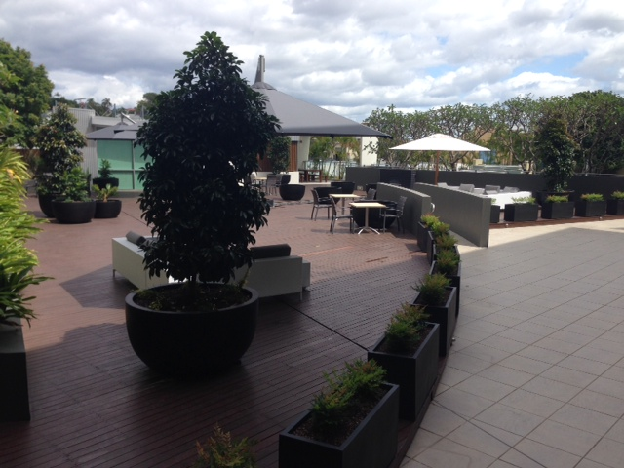
Confirmation by Reserve Bank of Australia that we are astute investors!
Some suburbs will be more popular than others, some areas will have more scarcity than others and, over time, some land will increase in value more than other areas. And of course these are the areas property investors should target, as that's where they'll get above average capital growth.
So, it didn't surprise when Luci Ellis, head of financial stability at the RBA recently confirmed that capital growth has been stronger in the inner suburbs of all our capital cities than in the outer suburbs.
For property, the physical reality is that it endures for a long time and is fixed in place.
But being in the 'right' kind of neighbourhood with the best amenities, close to commercial centres and other services, is more important to most people, if their willingness to pay for it is any guide. Newfarm, Newstead and Teneriffe now have a higher average price than Ascot, Hamilton and Clayfield.

Air Conditioning Maintenance updates
I wrote a few months ago about the fact that the air conditioning units in the complex are coming up to 10 years old and that they run on the old gas system which has a type of chemical in it that is harmful to the ozone layer and has been discontinued in production. This has several implications for us at Newstead Terraces. From next year the gas will no longer be available. If your system needs to be re-gassed it can’t be done and you are looking at installing a new system. To install a new system with the compliant gas variety all the pipes in the apartment need to be upgraded because the new gas runs at a different pressure and the old pipes will not cope with the new pressure, plus it is illegal to reuse the old pipes with the new gas.
Unit 1 has a dual head compressor style system, the same as all the other original units in the complex. Recently there was a motor burn out in one of the compressors. This is covered by insurance, but under my policy they depreciated the cost of the repair by 7% for each year of the unit’s life, so 70% depreciation on the quote to repair. The insurance will contribute approximately $800 towards repair or replacement. The quote to repair $3000. The quote to replace with a new Mitsubishi dual head compressor system, a brand chosen because of its quite operation ,its economical electricity usage and the parts availability track record ( all issues suffered with the McQuay systems currently in place)$11 000!!!! The quote is $11000, because we have to cut access hatches into the ceiling in two places to feed through the different sized and new pipes. I am sharing this information with you, because I believe we will start to see more motor burn out and gas refill maintenance issues as the complex ages. This is a quote for a two bedroom unit. Three bedroom unit owners will have to find more. This quote doesn’t cover repairing the access holes.
I have done a lot of soul searching over the last couple of days. Do I spend $3000 on a system that is deleted, hoping that it carries on for a few more years, and that the other compressor doesn’t burn out next year. In which case I will have sunk $6000 into an uneconomical, inefficient system that I can’t get more gas for, or do I bite the bullet and fork out the $11000 for a new system now.
Fortunately for me, I will be between tenants in early November and can get the work done without disturbing a tenant. The air con people say they need access for 3-5 days to get the job done, depending on how tricky the new piping instalment ends up being. If you are a landlord, you may have to factor in putting a tenant up in a hotel room for a few nights, or giving free rent for a week to compensate for the dirt and disruption. I have opted for the new system. What will you do when the time comes?
Hard Flooring Insurance
Lot owners with hard flooring, please be aware that any damage to your hard flooring is not covered by body corporate insurance. It might be prudent to check your contents insurance to confirm that you have sufficient coverage for damage to your floor.

September Vacancy Rates, Survey Results from REIQ for your interest.
Only REIQ members contribute information for this survey. It is very current and relevant to our area. The survey results support my current experience. Our properties are taking up to 4 weeks to fill at the moment, and our rents have dropped dramatically. I still believe that once construction next door is complete we will be back to our very strong position, and potentially improve on 2014 rental returns.
Quick facts about the September survey:
- 457 agencies surveyed
- 127,087 rental properties captured (24% of total bonds held by the RTA)
- 44 LGAs/regions/sub-regions published
- NB Only LGAs to have a minimum of 15 per cent sample size (ie % of total bonds held by the RTA) are published.
