Newstead Terraces News
June 2015
Hello everyone.
The work on the garden bed outside U04 and the lift stairwell has now been completed. The drainage issues in the garden bed could not be solved without expensive rectification works, so a simpler and cheaper solution was to fill the bed with gravel and put the plants into pots that would have room for them to grow into yet keep their roots out of any damp. The gravel will maximize any drainage. You can see from the photo how the concept works. This should keep our palms healthy and alive for many years to come. The black pots have been covered by a more decorative larger stone. The finished look is very neat and tidy.
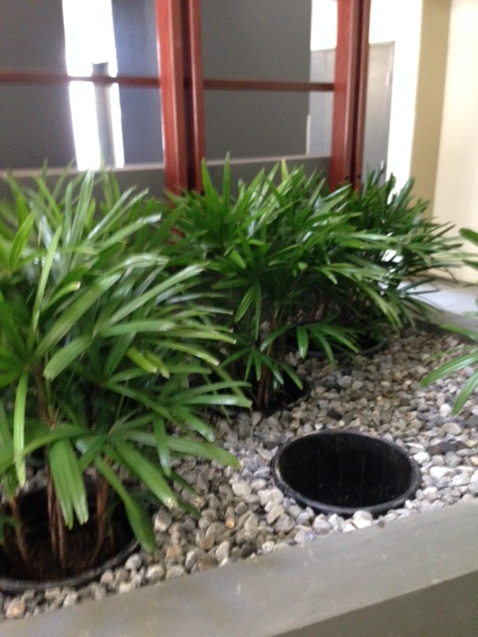
Beautification Project update
The special levies notice has been sent out for the for the deck beautification. As the AGM was postponed a month it was felt that more time should be given to everyone to gather the extra money together and therefore the date for the special levy payment has been extended to August. Thank you to all of you whom have paid promptly. This has enabled the committee to place the order for the furniture which is coming from overseas. We expect to see some of the furniture to start arriving by the end of July and our new large umbrellas installed at the same time. By the end of August it is anticipated that all the plants and pots will be in place. I am meeting with the landscaper on Thursday 18th June to finalize the plant and furniture placement. I am sure you will all appreciate that the project was unable to commence until the funds have been collected.
“The REIQ rental survey results” are out for the March 15 Quarter by Yvette Burton, REIQ research analyst.
After the typical spike in vacancies over the new-year period, the inner city vacancy rate was down 0.6 percentage points to 3.1percent at the end of March.
It should be noted however that he REIQ’s inner city figure does not yet capture the new stock coming onto the market. According to local agents, the true vacancy level is much higher.
Analysis of dwelling counts from CoreLogic RP data, the inner city unit market over 2014 saw an approximate increase of 4,400 new units compared with 2013. In comparison, the number of bonds held by the RTA had increased just shy of 4000 bonds, which indicates the trend in tenant demand is relatively in line with supply levels, for the time being.
While figures are approximates only, it is clear according to the local agents that there is an oversupply of stock in the inner city, and more is yet to come online. As a result many investors are giving rental incentives such as rent free periods as well as reducing the weekly rent in order to attract and maintain tenancies. Investors that are willing to do this during this period of oversupply are said to be achieving minimal vacancy periods, whilst those who aren’t responding to the market are seeing longer vacancy periods.
Rental demand is said to be further dampened by tenants either making the move to the outer Brisbane suburbs in search of more affordable rentals or are buying property further out at the same weekly cost of renting in the inner city.
My personal experiences March to June, are that at Newstead Terraces, we are seeing some increased vacancy times, but we are still maintaining our rental returns. I am still achieving $680 a week as new minimal rentals with up to 2 weeks vacancy. We have not yet started to really experience the impact of the construction next door. It is difficult to predict how much impact it is going to have on our rental returns. At this point we have seen several leases not renewed with tenants moving out before the construction begins, blaming the imminent noise disturbance as the cause for their departure.

New Work in the Complex this Month.
Work continues in the complex replacing rotten timbers in the pergola’s and pool room doors, and the Sauna is next on the list. The developers in many cases used a soft pine wood in many outdoor instillations, sometimes not even painting the top of the battens. This has left them exposed to the weather and overtime rot has set in. An example for your information is in the photo below.
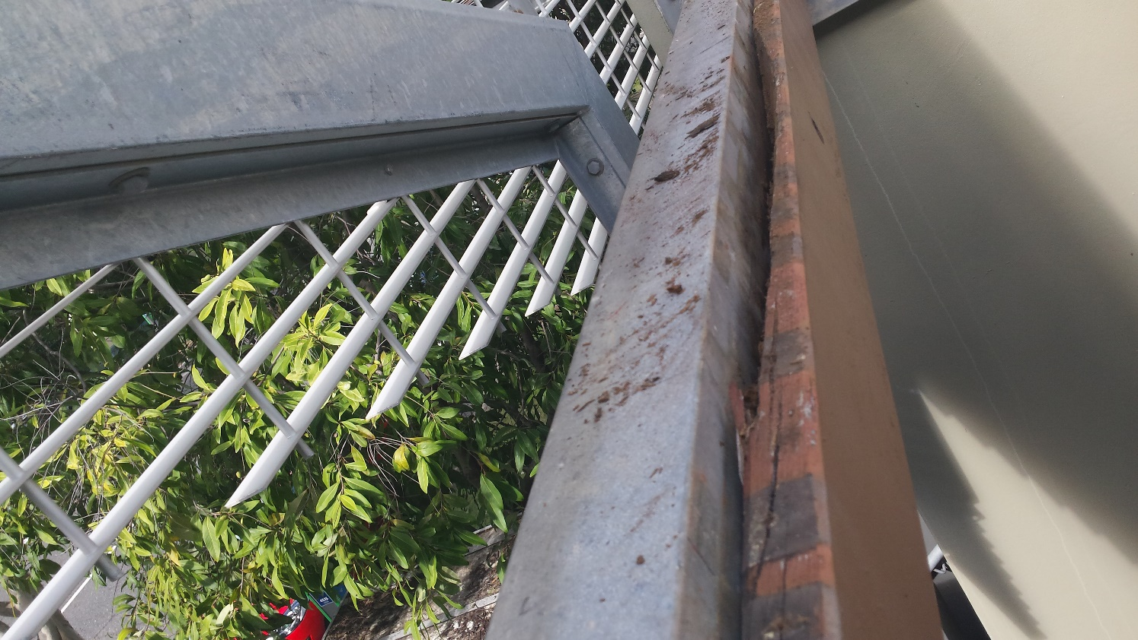

Sales in the new complex next door have progressed faster than the developers had hoped for, which means that they are on track to start work on the site in October. The prices that they are achieving for their product are higher than what we are experiencing for ours. This bodes well for the values of our properties and the value of the area. It is all good news for our investments in Newstead Terraces. We are in a booming area of Brisbane.
Vocus Communications are working in the neighbourhood.
You may notice Vocus Staff and its accredited contractors upgrading its communications network in the area over the next few weeks. This is part of an ongoing program to provide superior facilities to their customers. During this period Vocus will be excavating/boring under the footpath in front of our property.
Please be assured that any physical disturbance to the area outside our building will be fully restored at the end of the project to council’s specifications.
HAVE YOU WORKED OUT IN THE GYM WITH THE NEW TV? Go have a look, the treadmill will be less dreary now.
Wishing you all a great END of Financial Year, with smooth sailing through the data entry and tax returns.

G
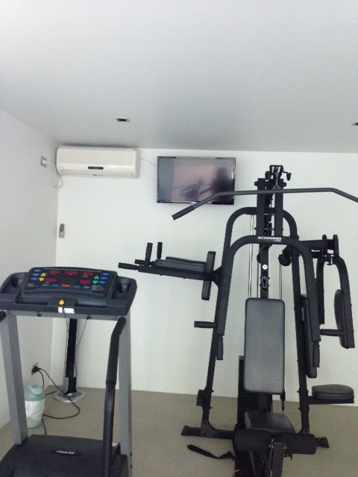New TV in Gym.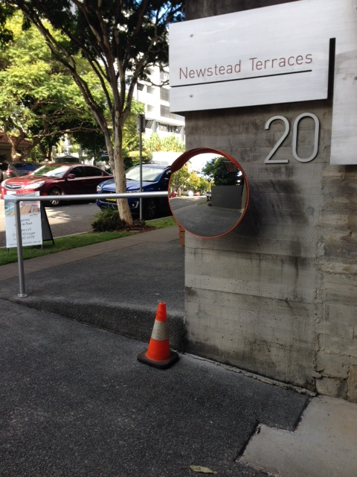Safety Mirror installed at Driveway Entrance. Now we can see pedestrians coming when exiting the property.

