Newstead Terraces News
October 2016
Median house price up in Brisbane in a quarter of surprises (From the REIQ)
The property market in the southeast corner of Queensland returned to positive territory this quarter, following last quarter’s contraction, and the Brisbane LGA median house price has grown 1.3 per cent to a new high of $635,000, the highest this has been in history.
REIQ CEO Antonia Mercorella said it had been a challenging quarter for the Queensland property market, with factors such as the lengthy federal election campaign and extensive uncertainty around the negative gearing debate impacting heavily on most markets.
“However, there has been significant focus on Queensland’s affordability and we have anecdotal evidence that investors from the southern states are once more returning to our markets,” she said.
“The Queensland housing market is doing what it does best – growing in a steady, sustainable way, consistently over the long term,” Ms Mercorella said
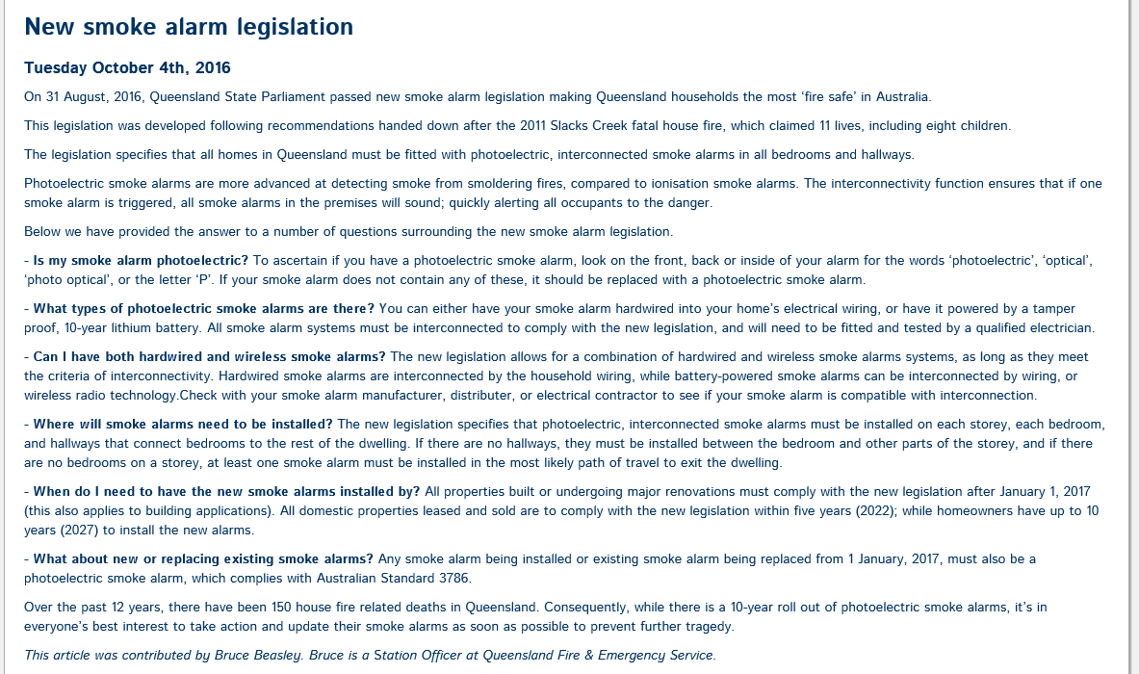
We will need to comply by 2022. Our current smoke alarms have a 10 years life span. Smoke Alarm Solutions are replacing expired smoke alarms with Photoelectric alarms, so if you are with Smoke Alarm Solutions you are compliant for the alarms you have. Additional Alarms will need to be installed before 01/01/2022. They are $229 each, and need to go into each bedroom.



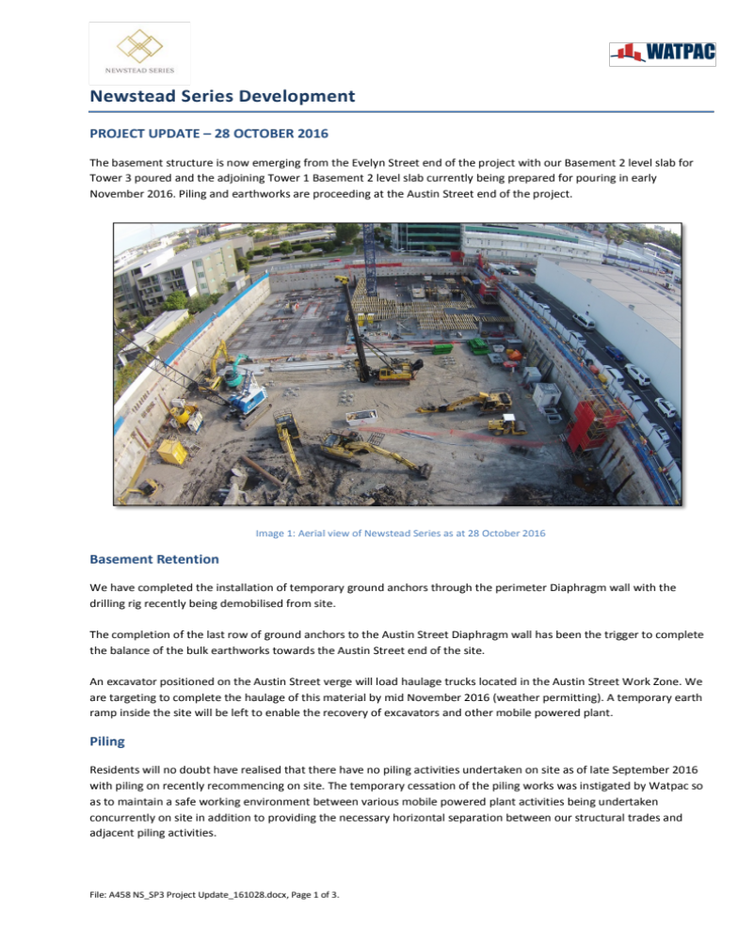


We are targeting to have the piling works completed by 16 December 2016 however there may be a possibility that these works will drift in the first half of January 2017.
Tower Cranes
Our first tower crane servicing the Evelyn Street frontage was erected on 1 October 2016.
Just for your information, when out of service, the tower crane will slew around depending upon the prevailing wind conditions. This is a standard arrangement of tower cranes so as to minimise the forces being transmitted through to the crane base.
The second (and potentially third tower crane) servicing the Austin Street frontage are scheduled for erection in early January 2017.
Evelyn Street Gantry Site Facilities
Watpac completed the erection of our twin deck site facilities on the Evelyn Street gantry on 22 October 2016. These facilities provide First Aid, Toilets, Lunch sheds and several site offices.
Watpac’s main project office has been established in the mezzanine of the 32 Austin Street premises (directly adjacent the Danish Club).
Services Connections
The main potable water supply for the Newstead Series project has been installed from an existing Queensland Urban Utilities main located in Austin Street.
We have recently installed the main storm-water connection in Evelyn Street with two remaining connections in Austin Street yet to be completed.
Concrete Structure
We poured our first B2 Basement level slab on 21 October 2016. Concrete will be typically conveyed into place via mobile concrete boom pumps setup on the Work Zone. Depending on the size of the pours, we may use two concrete boom pumps with two concrete trucks backing onto the hopper of each concrete pump (as was the case with the first B2 basement slab pour).

Traffic controllers will be working in Evelyn and Austin Street to Stop / Go or Contra Flow traffic to ensure the safe movement of vehicular and pedestrian traffic in and around the Work Zone. The outriggers of the concrete pumps will typically extend into the eastern active lane. It therefore becomes necessary for us to temporarily close this active lane and contra flow traffic around the western active lane. Watpac has permits in place with BCC for these temporary lane closures.
We will progress the Evelyn Street end of the project up to Ground level and commence the erection of the first precast concrete panels from Level 1 to Level 2 prior to Christmas.
Construction of pile caps will progress down at the Austin Street with these works ongoing up to Christmas.
Rostered Days Off
Workers in the construction industry are entitled to Rostered Days Off (RDO’s) during the course of the year. File: A458 NS_SP3 Project Update_161028.docx, Page 2 of 3.
Swimming Pool upgrades and Spa Repairs
After nearly two months of woes with spa leaks it looks as though we finally have the spa up and running and staying full. Thank you everyone for your patience during this very trying time.
Whilst the spa was empty we took the opportunity to upgrade the lights in the spa and both pools to LED and to do some repairs on the garden lighting in the pool area. Evenings around the pool will now be much better illuminated with our soft warm lighting in the gardens and paths and the LED lights in the pools.
Just a reminder to everyone that no glass is allowed in the pool area. This includes wine bottles, beer stubbies and glasses. If a sliver of broken glass gets into the pool, we have to remove all the water and refill the pool. This is a huge expense, and one you will be paying if you are the responsible party for the broken glass. It’s really not worth it. Have your drinks on the upper deck and leave the pool area for sunbathing and swimming.
Summer considerations
Please everyone be aware. We are outside now with the warner weather, glass balcony doors are open. Noise and smoke travel. If we are all considerate of the volume on the TV, the decibels of our conversations and the direction our BBQ and Cigarette smoke are travelling in, our neighbours will be much happier to know us and we them. Please get out and enjoy our beautiful common areas, but do leave them clean and use them in a considerate manner.
Have fun!
Georgina
PS Keep Sunday 4th December from 4.6pm free to join in the Christmas Drinks at Newstead Terraces BBQ area.

