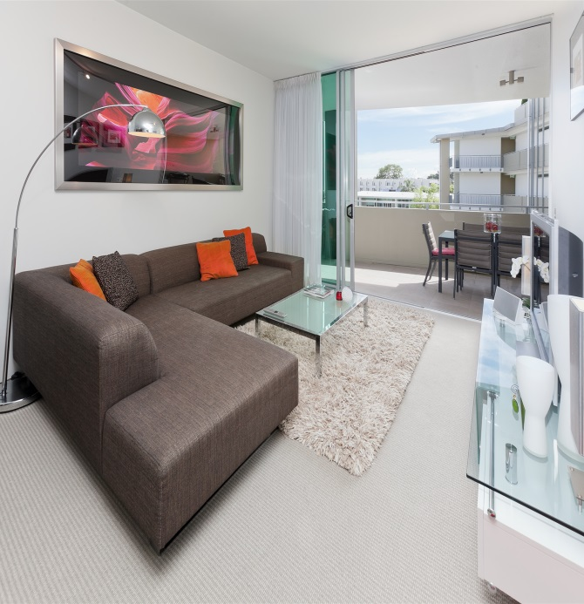
Repairs and Maintenance Budgeting
Good Management Practice

Every property investor knows that they have to budget for repairs and maintenance, but just how much do you budget for? When should you expect to have to carry out some of those bigger maintenance tasks? What am I required to maintain by law, and what can be left for more lucrative times? Can it be expressed as a percentage of income?
Tenants want to live in as nice a home as possible, no matter what their income level. Landlords want to maximize the return on their investment, whilst maintaining the value of their investment portfolio. This needs to be careful planned and programmed.
There are three types of maintenance – Emergency, Routine and Cosmetic. All have different tax implications and your strategy should be discussed with your Accountant.
- Emergency Maintenance occurs when pipes burst, fires break out, windows shatter, electricity or gas fails. They require immediate action, and usually can be covered by insurance.
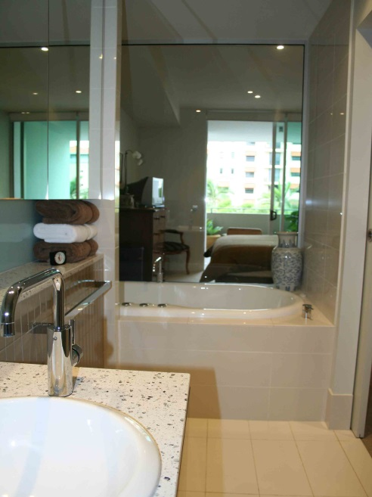
2. Routine Repairs are the day to day maintenance issues. Door hinges breaking, hot water thermostats failing, appliances failing, toilets running, transformers and light switches failing. Neither the occupants nor the property will be exposed to risk if immediate action is not taken, but the law will come down on you heavily if you do not effect timely repairs. When your property is brand new, your routine repairs will be much smaller percentage of your income, but as your property nears the 7 year mark, appliances will start to be beyond economical repair, and once the 10 year mark is reached, then you are going to experience greater repair expenses as items wear out, and need to be replaced. A percentage of the income should be budgeted for regular routine repairs, to keep your investment in good order.
- Cosmetic (Renovation) Maintenance comes into play around the 10 year mark. Walls will need to be repainted, floors repolished, carpets replaced, bathrooms and kitchens may have become dated and worn. Appliances that have not yet failed, may very soon. This is where you need to have been putting money aside in a sinking fund for the renovation of your property. This doesn’t have to be a major renovation, but the updating of some door hardware, repairing of stone bench topes, regrouting of tiles and replacing chipped tiles. Small jobs that will result in giving the property a fresh look. This is the area that has the greatest impact on the rental return of your property. Keeping your investment fresh and up to date helps to maximize interest in your property and upward pressure on rental returns achievable.
Maintenance Expenses, Costs and Time Frames
Indicative Estimates only
Type of Expense | Time Frame | $ Value
Replace Window Treatments (approximately as it depends on what type of blinds etc you have | Every 5 to 7 years | $2000
Replace White Goods (budget brands) | Every 7 years
Replace White Goods ( prestige brands) | Every 10 years
Repolishing Timber Floors, floating floors, will get two polishes out of boards and last 10 years | 5-7 years
Replace Air conditioning plant | 7 years
Replace Carpet, budget makes | 5-7 years | $3000
Replace Carpets, better quality makes | 7-10 years | $5000-$6000
Painting internally- touch ups | 3-5 years | $1000
Painting internally freshen up with new paint | 7-10 years | $5000-$6000
Painting externally ( a Body Corporate expense) | 7-10 years
Renovate Kitchen ( cosmetic, polish bench tops, repaint doors, replace handles) | 7-14 Years
Renovate Bathrooms ( cosmetic, replace shower screens, and mirrors, regrout tiles) | 7-14 Years
Gardens – annual top up of soil and mulch | 1 Year | $500
Gardens- overhaul some plant varieties | 5 Years | $1000-$2000
Gardens- major renovation  Don’t underestimate the impact a good garden has on the appeal of a property | 10 Years | $5000-$10000

The $ estimates are for a 2 bedroom, 2 bathroom apartments.
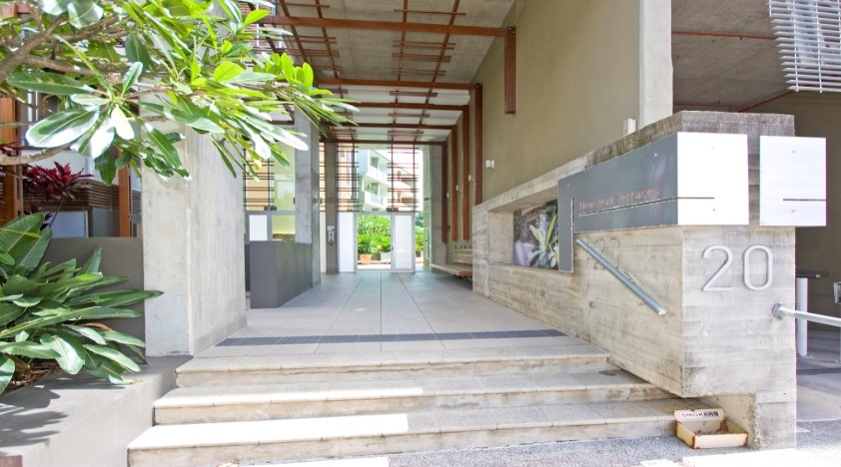
Newstead Terraces was constructed in 2005/2006.

