16 July 2021

Important Information for Owners: Plumbing/ Water Ingress

As our building ages, we are starting to see more incidents of water ingress as a result of plumbing issues. Plumbed Refrigerators, Washing Machine connections, concealed flexible water pipes to toilets/sink mixer taps and shower recess where the water proofing is starting to fail, and it is anticipated that we will start to see internal lot plumbing failures. None of this is out of line for a building reaching the age ours is.

The impact of these plumbing issues is an increase on insurance claims which will start to impact on the Body Corporate’s insurance and also on your insurance.

- Claims history starts to reduce the appetite of insurers to offer insurance, and it impacts on the terms offered.
- While we have been able to keep our insurance premiums in check as much as possible the premiums are increasing.
- We will start to see pressure to increase our excess premium from $1000 to reduce our overall insurance expense. The excess is something that can be passed onto a lot owner to pay in some circumstances, but none of us have an appetite for large excesses that need to be paid personally.

Not all water ingress issues can be attributed to the Body Corporate insurance. As Lot owners, you need to make sure that you either have water ingress insurance, or the capacity to cover the cost of repairs not covered by the Body Corporate. The Committee is writing to all Lot Owners to advise them of steps being taken by the Body Corporate to mitigate plumbing incidents and their impacts, and importantly, what Lot Owners can do to protect their property and that of their neighbours.

What has the Body Corporate done:

- Negotiated in the best interests of Lot Owners to obtain favourable terms for our Body Corporate’s insurance including maintaining the current Excess for Water and Flood claims.
- Obtained a report from the Body Corporate’s plumber, identifying some checks and preventative maintenance that can be undertaken.

- In this notice, we are informing Lot Owners
- What they can do to reduce the risk of a failure of their plumbing installations.
- Advise on what to do in a plumbing emergency.
- A reminder to ensure Lot Owner’s insurances are up to date.
- A reminder that in strata living you have an obligation to make sure you are not inconveniencing your neighbours by not doing all you can to keep your property in good order.

What can Lot Owners do?

Water leaks and floods can be disruptive and stressful for Lot Owners. While the Body Corporate’s insurance covers some claims, if the total damage is less than $1000 the Lot Owner may be responsible for the full repair cost. Furthermore, if a claim is made, sometimes the lot Owners will be responsible for payment of the entire excess ($1000). Often the repair bill is divided between the lot owner and the body corporate. It is therefore in the best interests of Lot Owners and the Body Corporate for Lot Owners to be proactive in assessing their plumbing maintenance; ensuring they have correct insurance in place; and knowing what to do in a plumbing emergency.

HAVE YOUR PLUMBING REGULARLY INSPECTED AND MAINTAINED:

Lot Owners are responsible for maintaining certain plumbing fitting and fixtures. The Body Corporate’s regular plumber has recommended Lot Owners have the following inspected and, if necessary, repaired/replaced.

- Mains water isolation taps Washing Machine taps and hoses
- Fridge water outlets Basin Mixer taps and hoses
- Kitchen sink mixer and hoses Toilet taps and hoses
- Dishwasher tap and hose Balcony tap
- Shower recess waterproofing Laundry flooring waterproofing

The Body Corporate recommends all Lot Owners arrange a plumbing inspection as soon as possible using your preferred plumber, and to take advantage of a free service from Megasealed to check the waterproofing in their shower recesses and laundry flooring. The trades will then quote for any work required.

For your convenience, the Body Corporate’s usual plumber can assist Lot Owners with an inspection and advise on any work needed. If you wish to contact them for a quote for a plumbing inspection their contact details are

Pipemaster Plumbing - David Scwede 0410567351
Megasealed 3287 9664

ENSURE YOU HAVE CURRENT CONTENTS INSURANCE FOR YOUR LOT:

Whether you are an Owner Occupier of a Landlord owner, it is important you have a current Contents policy in place to cover items not insured under the Body Corporate’s policy (for example, window furnishings, carpet etc). Importantly, check on the water ingress component of your policy, and if you don’t have it, enquire about getting it.

If you have any queries on what is covered by the Body Corporate’s Policy and what needs to be covered under Lot owners’ contents policies, please contact Archers Body Corporate Management or your insurance company.

WHAT TO DO IN A PLUMBING EMERGENCY:

FOR A LEAKING OR BURST PIPE:

- Isolate the water source immediately.

- Each apartment has a cold water isolation tap in the outside cupboard where your air conditioning compressor is. Most units also have their hot water system in this cupboard. The lever can be located at height above the air con or hot water system.

Lot owners should identify where their isolation valves are in case of emergency.
(Your plumber may be able to assist).

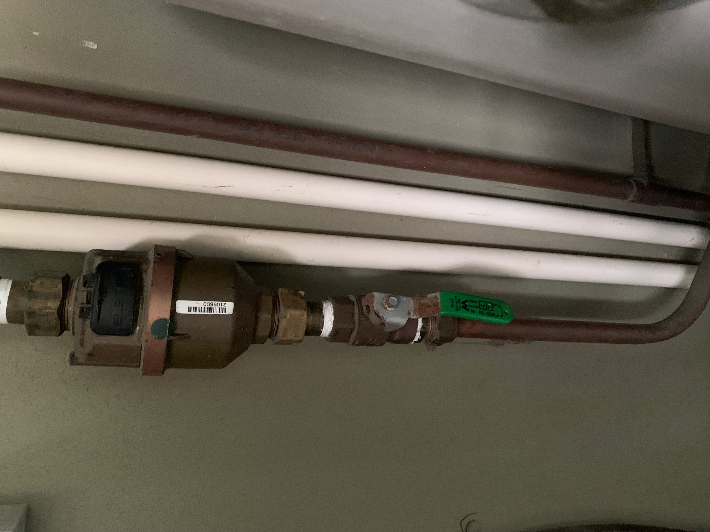

Water Shut off Valve

Turn the green lever to
shut off water supply to
your unit.

Located in cupboard on
your terrace/balcony.

- Mitigate the damage:

Remove as much water as you can as quickly as you can. Friends, neighbours or professionals may be able to help you.

If you need assistance to stop the leak or mitigate the damage, the Building Manager will be able to advise on the best source of help for each individual issue.

A disaster recovery company (for example, the Body Corporate currently uses Jacob Kemp from Total Disaster Recovery 0423 949 023) may be needed ASAP to commence the process of drying out any damaged materials.

Please be aware, if the issue is a lot owner responsibility, you or your contents insurer will be responsible for any costs.

- As soon as possible – notify the Building Manager and the Body Corporate Manager (Archers Body Corporate management) who will advise on whether an insurance claim can be lodged for the damage and any emergency recovery work required.

FOR OTHER TYPES OF PLUMBING ISSUES AND LEAKS:

Other plumbing issues should be attended to asap, even if they are not an emergency:

- Dripping taps/showers/running toilets.
Control small leaks with buckets or towels, or by turning off the isolation valve. Arrange a plumber to repair as soon as possible.

- Leaks you cannot see.
If you are experiencing waste odour, sewerage smells, or notice evidence of a water leak such as water damage or mould, or hear running or dripping water that is a new sound, call a plumber asap.

- Blocked/gurgling drains
If you are capable, try a plunger on toilets and sinks. If unsure call a plumber asap.

- Gas leaks (gas odour)
Immediately isolate gas by turning of the appliance, and if necessary go down to the garage and turn off your gas isolation switch. You will have received a gas switch map when you moved in. Familiarize yourself with where your gas switch is.

- Rainwater ingress
Remove as much water as you can and try to capture any water coming in by placing a bucket or towel under the drip. Notify your building manager.

- Going on Holidays for an extended period of time
Turn off your water at the main isolation valve. See image above to locate the valve. It is located in the outdoor cupboard on your terrace.

